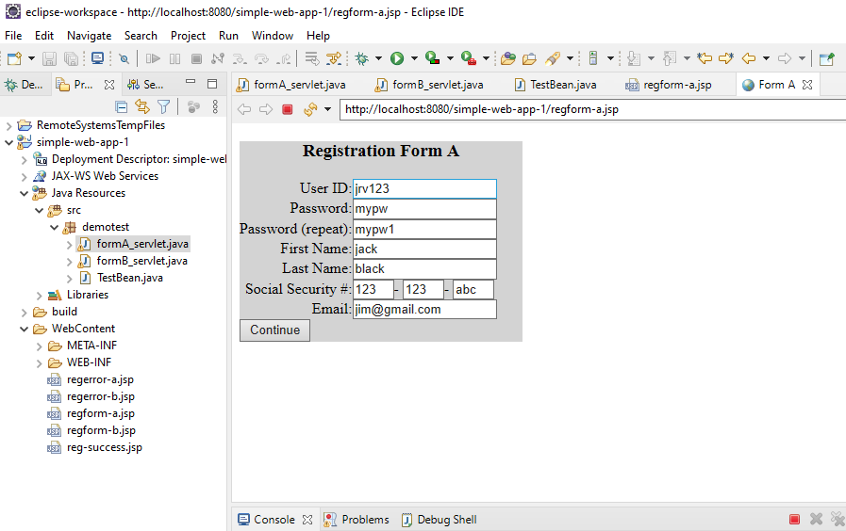

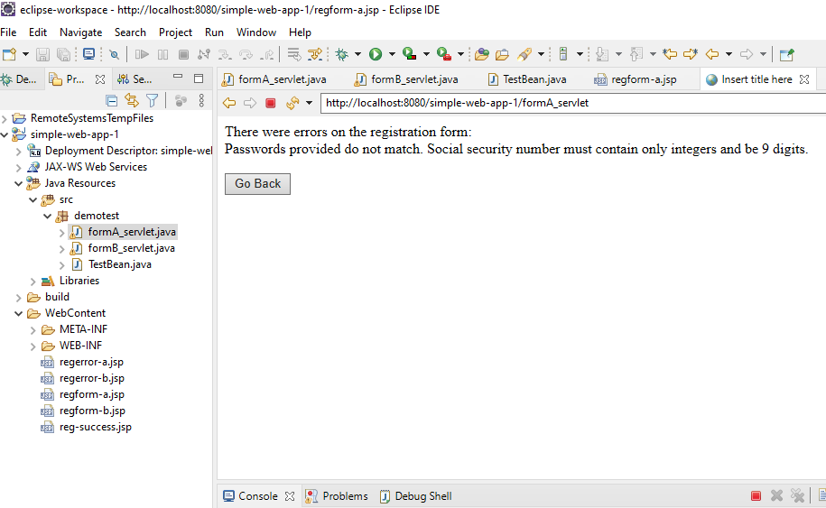

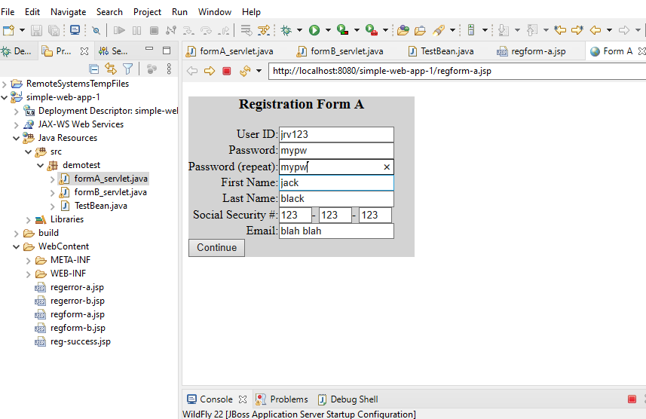

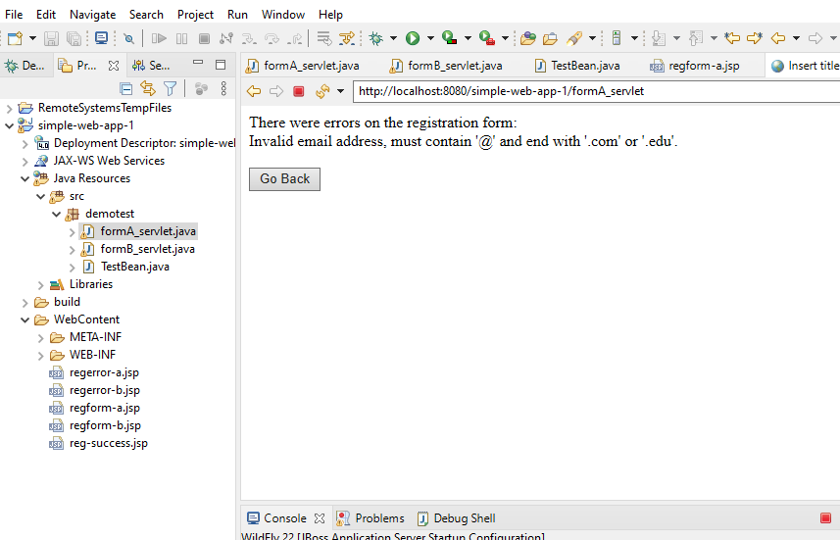

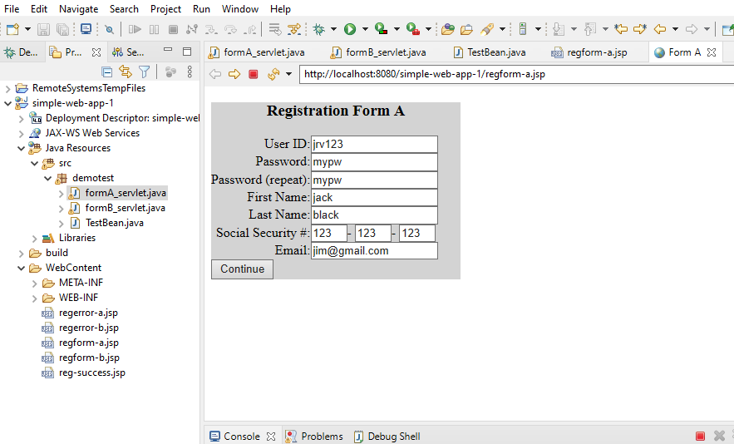

AFTER REGISTRATION FORM COMPLETED CORRECTLY, THE USER IS DIRECTED TO FORM B.

IF USER SELECTS ‘RESET BUTTON’ THE FIELDS WILL BE RESET ON FORM B PAGE.

OTHERWISE THE INPUT VALIDATION WILL TAKE PLACE AND GIVE ERROR MSG OR SUCCESS PAGE.

